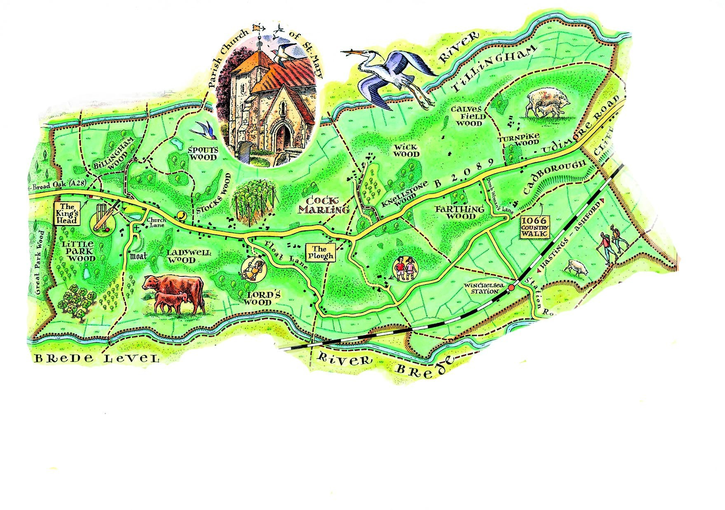
Udimore Parish Council Newsletter
www.udimore.org Issue18 January 2016
Next Council meeting  The Parish Council will meet on  Wednesday 20th January 2016 at 6.30pm in Udimore Community Hall.  All are welcome to attend | Udimore Parish council  The next meeting of the parish council will be on 20th January at 6.30 in Udimore Community Hall.  The agenda will include:  - The 2016-17 budget and precept  - Consideration of a request relating to the graveyard (see the following item)  - Vehicle activated signs and traffic islands  Graveyard Survey  The parish council has been approached by Fr Martin with a request that the PC makes a contribution to the cost of a proposed survey of pat of St Mary’s churchyard. Fr Martin explains that the churchyard is full and they propose to apply to the diocese for permission (known as a faculty) to enable part of the churchyard to be re-used for burials.  The application requires an accurate survey of the part of the churchyard proposed for re-use which is in the north-east from the chancel wall to the road.  The request to the PC has been made because Fr Martin and the Parochial Church Council feel that residents would want to see the churchyard continue in active use rather than it being closed  permanently and burials taking place elsewhere. Before considering this matter at its next meeting on 20th January at 6.30pm the PC would welcome views of residents on whether it should contribute out of public finds to the proposed survey which would directly benefit the families of those residents who would expect to be buried at St Mary’s.  Please respond by email and/or attend on the 20th when contributions from the floor will be welcomed by councillors.
Your councillors
Bob Turgoose, Chairman
01424 882657 bobturgoose@yahoo.co.uk
Keith Dean, Vice Chairman
01424 882206 kdean@clfarm.co.uk
Colin Knight
01424 883246
Colin.knight30@virgin.net
Leonie Wheeler
01797 222009 wheelersflp@googlemail.com
Louise Fuller
07753 565122
louandterry@john-lewis.com

Clerk: Sarah Willoughby 01424 813785/05755 126837 email: udimorepc@hotmail.co.uk Parish council website: www.udimore.org Newsletter editor: Bob Turgoose

