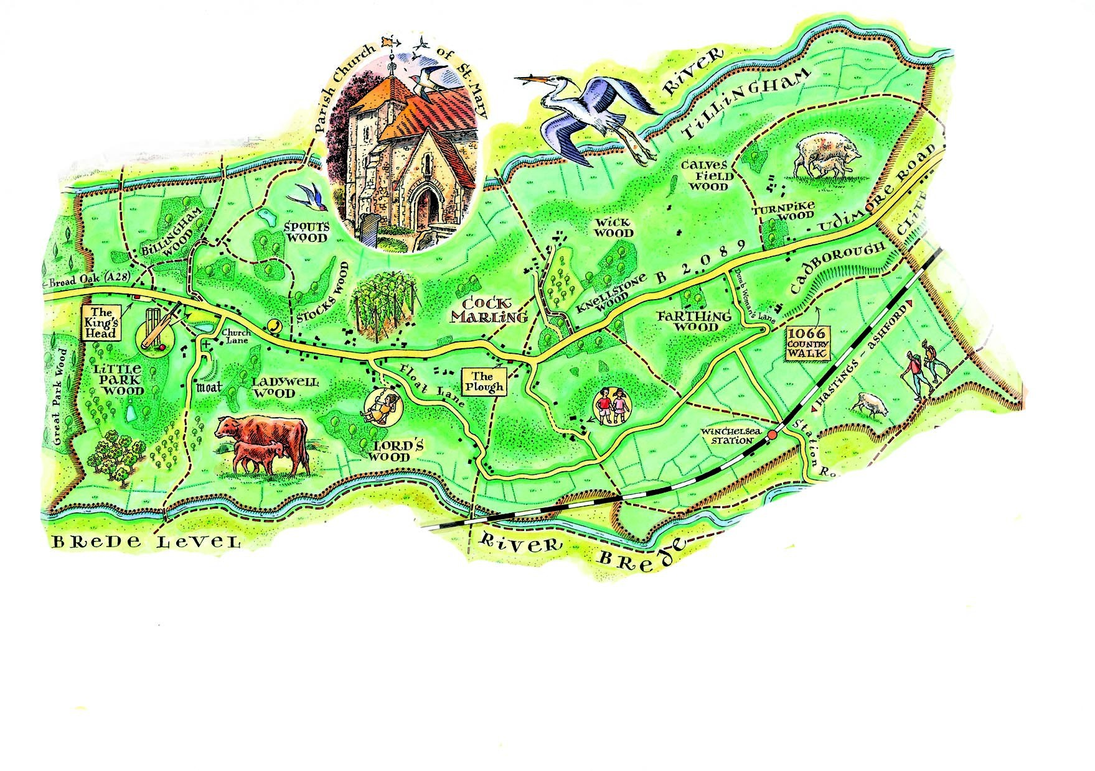
Udimore Parish Council Newsletter
www.udimore.org Issue 23 January 2017
Next Council meeting  The Parish Council will meet on  Wednesday 18th January 2017 at 6.30pm in Udimore Community Hall.  All are welcome to attend | November meeting of the parish council  The council considered its budget for 2017/18 and the related precept to be paid by residents. It also discussed the practicalities of obtaining a defibrillator for Udimore.  January meeting of the council  The council will decide its budget for 2017/18 and set its precept. In the current financial year the council has underspent its budget because it has not been possible to identify any highway improvements which are both affordable by the council and are likely to bring significant benefits to residents. As a consequence the parish council’s cash reserves can be reduced to a more prudent level when it sets the budget and the precept.  Defibrillator  It has been suggested that Udimore should acquire a defibrillator. The cost would be about £1,000 plus installation. The council considered the practical aspects of a defibrillator including where it would be located and how residents would be informed of its location and use. A defibrillator is designed to help someone who has suffered a heart attack until the ambulance service can attend. The advice we have seen indicates that in these circumstances the first two to three minutes after an attack are vital; the defibrillator should be used in this period and other first aid also applied.  In Udimore it is difficult to find a location which can be accessed in such a short time period. The community hall is the obvious choice but how many residents in the event of a family member suffering a heart attack could reach the hall, retrieve the defibrillator from its case, return home and commence its use within a maximum of three minutes?
The agenda at a glance:

Budget for 2017/18

Planning applications

Defibrillator

Your councillors
Bob Turgoose, Chairman
01424 882657 bobturgoose@yahoo.co.uk
Keith Dean, Vice Chairman
01424 882206 kdean@clfarm.co.uk
Leonie Wheeler
01797 222009 wheelersflp@googlemail.com
Louise Fuller
07753 565122
louandtez@gmail.com
Diane Hayes
01797 229734
tndhayes@btopenworld.com

Clerk: Sarah Willoughby 01424 813785/05755 126837 email: udimorepc@hotmail.co.uk Parish council website: www.udimore.org Newsletter editor: Bob Turgoose
FRIENDS OF ST. MARY’S CHURCH, UDIMORE
invite you to a
NEW YEAR’S BRUNCH
on
SATURDAY, 28th JANUARY
9.30 – 11.30 a.m.
in St Mary’s Community Hall

Egg, Bacon, Sausage, Beans,
Tea and Toast - £8.00
Continental Breakfast - £5.00

All money raised goes towards the upkeep of
St Mary’s Church, Udimore

FRIENDS OF ST. MARY’S CHURCH, UDIMORE INVITE YOU TO
DIGGING UP THE PAST
SUE LEE
our own local renowned archaeologist will be talking on

SATURDAY, 18TH FEBRUARY
At St Mary’s Community Hall, Udimore
3.00 – 5.00 p.m.
Tickets £7.50 to include tea and cake
Tickets in advance from committee members:-
Sue Rowan 01424-882681
Richard Holmes 01797 223055
Gillian Rothery 01424 882774
Liz Turgoose 01424 882657
All money raised will go towards the upkeep of St. Mary’s Church, Udimore

Forthcoming parish council meetings will be held in Udimore community hall at 6.30pm on the following dates:
2017 2018
15th March 17th January
17th May 21st March
19th July 16th May
20th September 18th July
22nd November 19th September
21st November
Udimore planning applications.
All planning applications are decided by Rother District Council.
Udimore Parish Council is always notified of new applications in the parish so that it can submit relevant local information or comments to the planning department at Rother DC.
Since your last newsletter there has been one planning application:

RR/2016/3212/P Rose Cottage, Udimore Road, Udimore. Construct an additional vehicular access parallel to the existing in order to form an independent access to the field.

Full details of all applications and decisions can be found at www.rother.gov.uk

