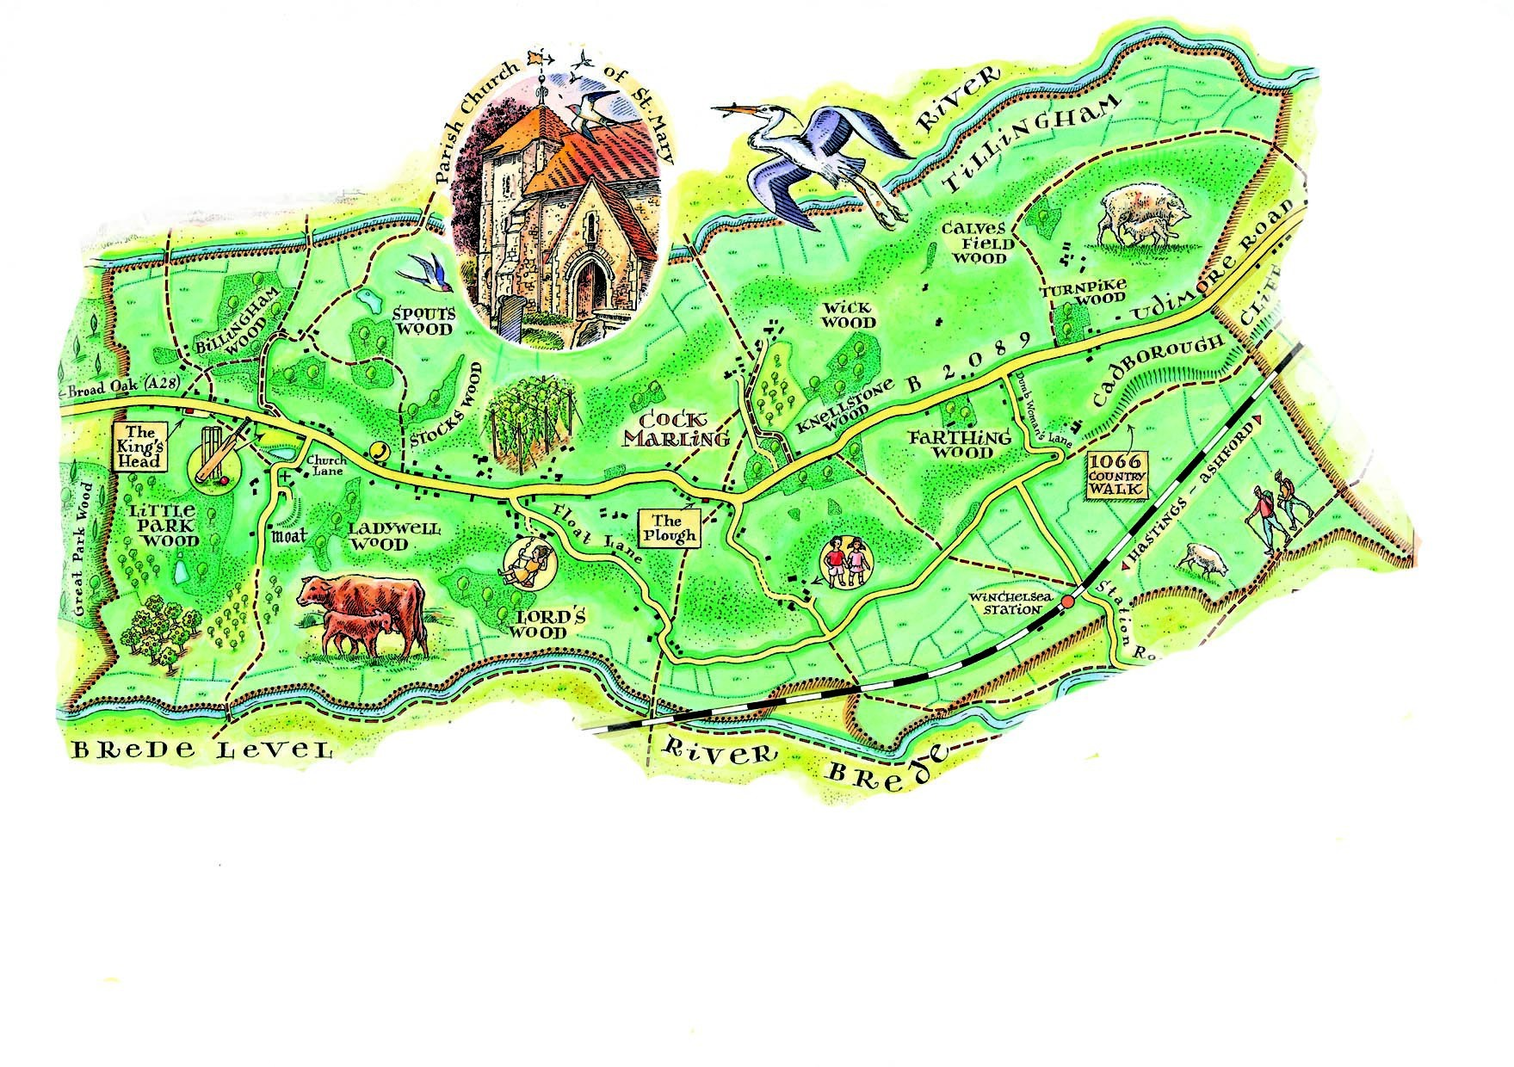
Udimore Parish Council Newsletter
www.udimore.org Issue 20 July 2016
Next Council meeting  The Parish Council will meet on  Wednesday 20th July 2016 at 6.30pm in Udimore Community Hall.  All are welcome to attend | Parish Council Meetings on 10th May and 29th June  At the meeting on 10th May, Bob Turgoose was re-elected as chairman and Keith Dean as vice-chairman. The council decided to object to proposals regarding electoral boundaries for county council elections made by the local Government Boundary Commission (LGBC). They have proposed that Udimore be combined in an electoral division with Salehurst, Ewhurst, Northiam, Beckley and Peasmarsh and separated from Brede and Marsham Valley.  The parish council considered that on grounds of long established community links with Brede, Udimore should continue to be in the same electoral division for county council elections as Brede.  LGBC will reply by 20th September on whether they support the Parish Council’s views. The next county council elections will be held in May 2017.  On 29th June the council held a short extraordinary meeting to formally agree the 2015-16 accounts in advance of them being passed to the external auditor.  Councillor Colin Knight  Colin Knight has resigned from the parish Council following his move to Catsfield.  On behalf of his fellow councillors I thank Colin for his many contributions to the council since 2007. In particular drawing on his experience with Sussex Police, he has helped the council in its contacts with ESCC Highways and with local police commanders.  I would also like to thank Stella Knight, who for many years was our tree warden, for her contributions to the parish.  Colin and Stella will be missed.
The agenda at a glance:

Planning applications for Udimore garage site

Highways

Your councillors
Bob Turgoose, Chairman
01424 882657 bobturgoose@yahoo.co.uk
Keith Dean, Vice Chairman
01424 882206 kdean@clfarm.co.uk
Leonie Wheeler
01797 222009 wheelersflp@googlemail.com
Louise Fuller
07753 565122
louandterry@john-lewis.com

Clerk: Sarah Willoughby 01424 813785/05755 126837 email: udimorepc@hotmail.co.uk Parish council website: www.udimore.org Newsletter editor: Bob Turgoos
Clerk: Sarah Willoughby 01424 813785 or 05755 126837 email: udimorepc@hotmail.co.uk
Ash Dieback
Ash dieback is a fungus disease of ash trees first identified in the UK in 2012. It kills most ash trees. There is no treatment or preventative measures available at present. It is hoped that some ash trees will be shown to have natural resistance and that breeding from them may be possible. Young trees can be killed rapidly but older trees can survive for several years.
Some of the ash trees in Udimore are showing symptoms of die back and Val Morin, our tree warden, has identified about a dozen trees throughout the village which will be monitored regularly. She has taken photos of these ashes in June 2016 and photos will be taken regularly in future.
If you have an ash tree on your land please keep an eye on it. The most noticeable effects of dieback are blackened and shrivelled leaves and death of parts of the tree’s crown, causing bare branches. The advice of the Forestry Commission is that the likelihood of infection is not a justification to fell or prune ash trees, provided that there are no safety issues.
Many of the trees that grow alongside the B2089 and overhang it are ashes. The concern of the Parish Council is that as these trees die falling branches will pose a hazard to passing traffic, power supplies and telephone or broadband connections. We will monitor roadside trees and report those that seem to be imminent hazards.
If you would like any advice on ash dieback Val Morin will do her best to help. She can be contacted through the parish clerk or directly on 01797 227671.
We have many fine ash trees in prominent positions in Udimore, for instance along Church Lane and near the Plough, and their loss will change the appearance of the village.

Udimore planning applications.
All planning applications are decided by Rother District Council.
Udimore Parish Council is always notified of new applications in the parish so that it can submit relevant local information or comments to the planning department at Rother DC.
Since your last newsletter there have been four planning applications:
RR/2016/1652/P Charivari, Udimore Road. First floor extension to form shower suite
RR/2016/1554/P Udimore Garage. Demolition of existing building and erection of one detached dwelling
RR 2016/1437/P and 1438/L Mill Lodge, Udimore Road. Installation of outside oil boiler and works to listed building.
Full details of all applications and decisions can be found at http://www.rother.gov.uk/article/361/Online- Applications-and-Decisions

Churchyard Survey
The survey of part of the churchyard, which the Parish Council agreed to meet 50% of the costs, has now been completed.
The next step is for the Rector to include the survey report with other papers in a submission to the diocese requesting that the churchyard continues to be used for burials.

Co-option of a councillor
As following Colin’s resignation there has been no call by at least 10 electors for a by-election, the parish council is now able to take steps to co-opt a councillor to fill the vacancy until the next election of the whole council in Spring 2019.
The co-option will be on the agenda for the next election.
Parish council website: www.udimore.org Newsletter editor: Bob Turgoose

