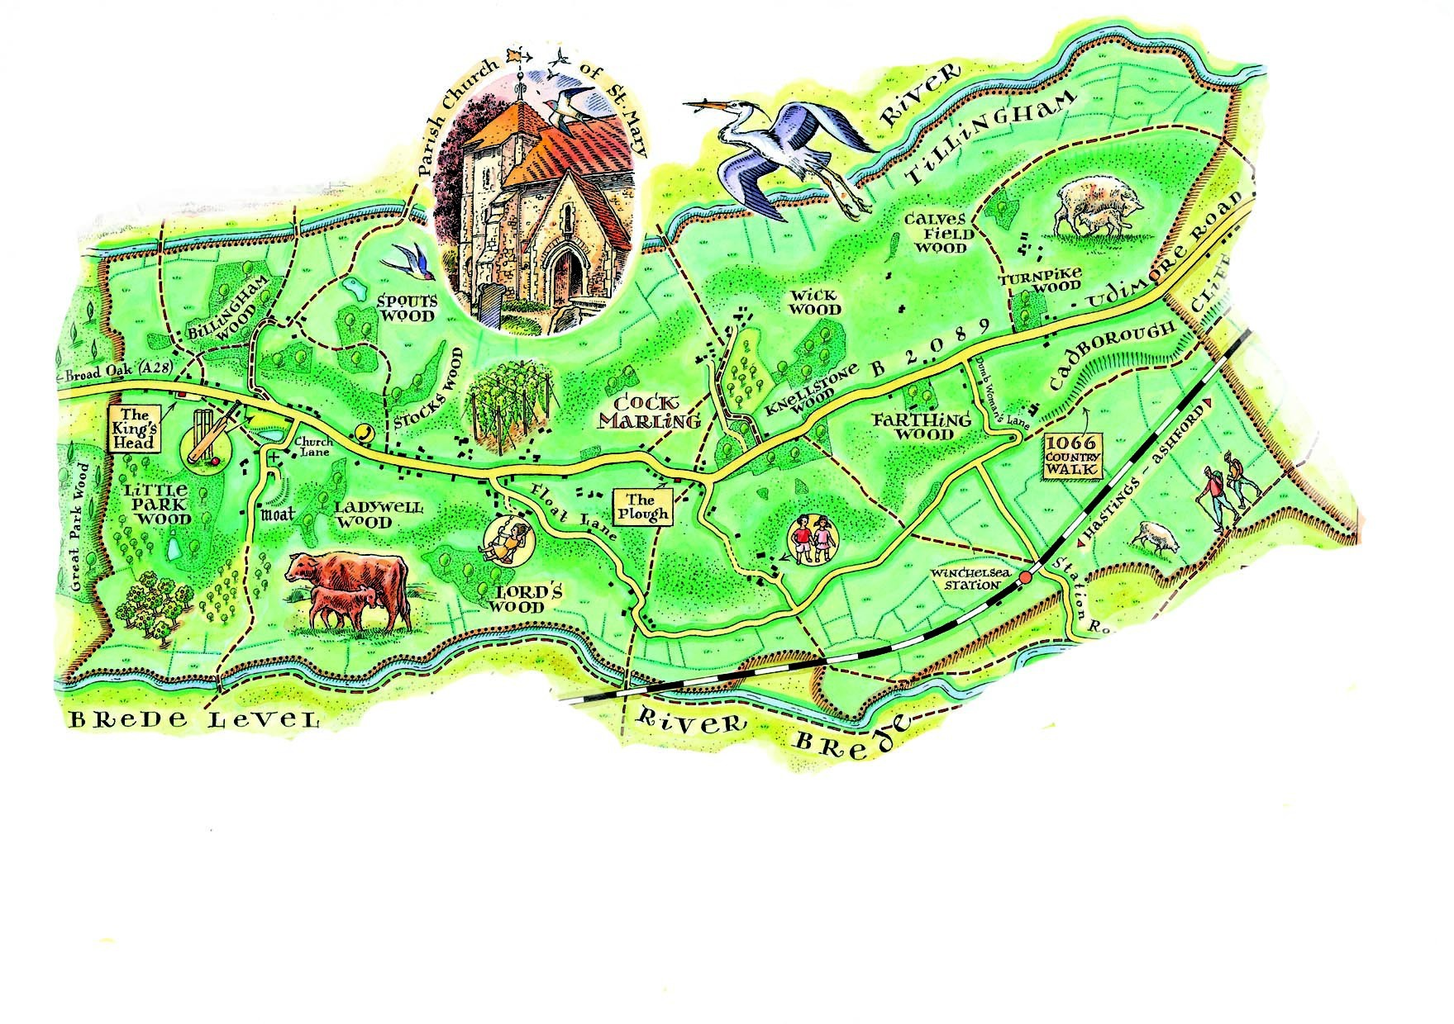
Udimore Parish Council Newsletter
www.udimore.org Issue19 March 2016
Next Council meeting  The Parish Council will meet on  Wednesday 16th March 2016 at 6.30pm in Udimore Community Hall.  All are welcome to attend | Udimore Parish council meeting on 20th January 2016.  Precept for 2016/17  The parish council agreed a budget for the 2016/17 year of £5,700. At the end of the current financial year the parish council will hold reserves of about £9,000. Recommended reserves to cover unexpected costs are between three months and six months expenditure, which in the case of Udimore means a maximum of £3,000. In addition, parish councils can hold reserves to meet the costs of known future projects. At present we have no definite projects in the pipeline, but we continue to investigate traffic calming measures for the B2089.  In light of the council’s strong financial position the council decided to reduce the precept to £5,500 for 2016/17. At present it is £5,800. The reduced precept plus a gant of £190 from Rother District Council will give Udimore Parish council a total income next year of £5,700, in line with the agreed budget. Any expenditure on the B2089 in excesss of the budgeted £500 would be met out of reserves.  Graveyard Survey  The parish council decided that it wished the churchyard to continue to be available for burials. We agreed a donation of £230 to the Parochial Church Council, to meet 50% of the expected costs of a survey of part of the churchyard.
The agenda at a glance:

Highways

Church gate post repair

Car park at St Mary’s Hal

Remuneration for councillors

Your councillors
Bob Turgoose, Chairman
01424 882657 bobturgoose@yahoo.co.uk
Keith Dean, Vice Chairman
01424 882206 kdean@clfarm.co.uk
Colin Knight
01424 883246
Colin.knight30@virgin.net
Leonie Wheeler
01797 222009 wheelersflp@googlemail.com
Louise Fuller
07753 565122
louandterry@john-lewis.com

Clerk: Sarah Willoughby 01424 813785/05755 126837 email: udimorepc@hotmail.co.uk Parish council website: www.udimore.org Newsletter editor: Bob Turgoose
Clerk: Sarah Willoughby 01424 813785 or 05755 126837 email: udimorepc@hotmail.co.uk
Udimore planning applications

All planning applications are decided by RotherDistrict Council.

Udimore Parish Council is always notified of new applications in the parish so that it can submit relevant local information or comments to the planning department at Rother DC.

Since your last newsletter there have been three planning applications:
RR/2016/401/TN Opposite Gate Cottages, Udimore Road. RR/2016/403/TN Opposite St Margarets, Udimore Road RR/2016/523/TN At the side of 1 The Green, Udimore Road. All three applications are for the Installation of high speed broadband cabinets

Full details of all applications and decisions can be found at http://www.rother.gov.uk/article/361/Online- Applications-and-Decisions

Annual Parish Meeting 10th May 2016
The Annual Parish Meeting and the annual meeting of the Parish Council will be held on TUESDAY 10th May in the community hall.
The Annual Parish Meeting will commence at 6.30pm. The annual Parish Council meeting will follow, not starting before 7.30pm. Wine and soft drinks will be available between the two meetings.
Please note the change of day. After May parish council meetings will revert to the usual Wednesdays. The Annual Parish Meeting is our opportunity to question the parish council about its actions and to make suggestions as to the Council’s priorities.
Please attend if you can.
Vehicle activated signs and traffic calming
Working with the County Council, the parish council has investigated the installation of vehicle activated signs (VAS) along the B2089. The cost of these signs ranges from £2,000 to £4,000 each, excluding installation. Costs depend on the signs size and the detailed specification. Installation in Udimore would be expensive because of the need to provide a mains electricity supply to each sign. Solar panels were looked at but many of the best sites for the signs were too shady for solar panels to operate.
Studies elsewhere have shown that VAS bring about only modest reductions in speed of some 3 – 4 mph. the parish council therefore decided it would not consider VAS further.
The parish council continues to look into traffic calming measures on the B2089.

Parish council website: www.udimore.org Newsletter editor: Bob Turgoose

