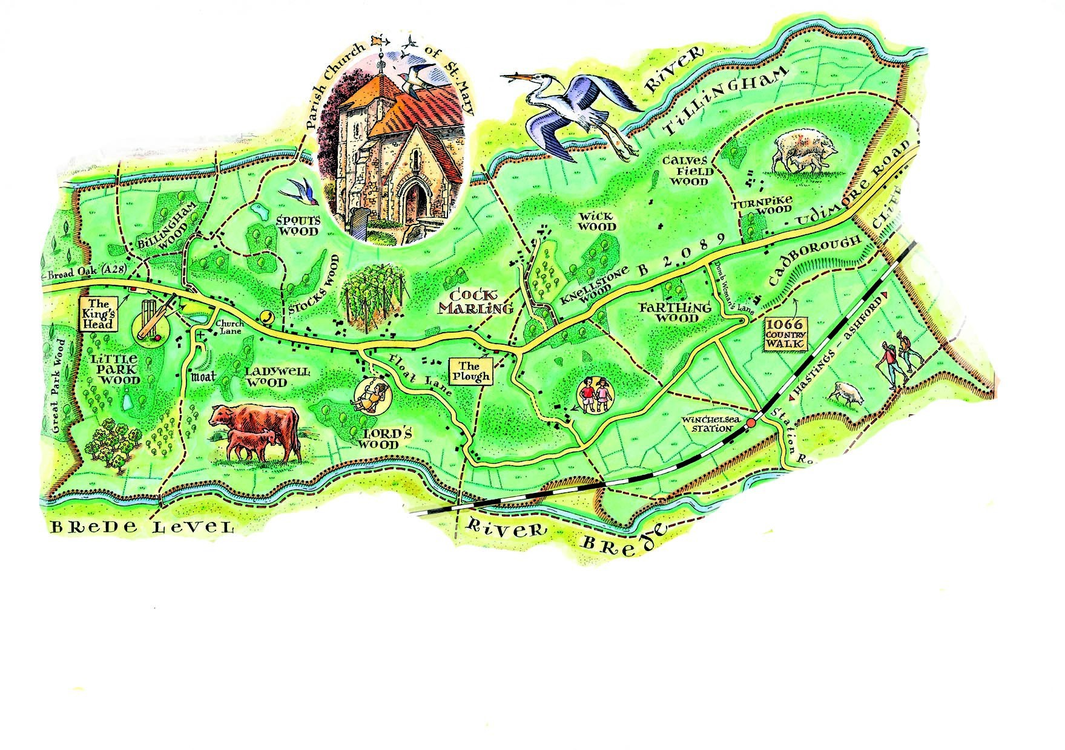
Udimore Parish Council Newsletter
www.udimore.org Issue 24 March 2017
Next Council meeting  The Parish Council will meet on  Wednesday 15th March 2017 at 6.30pm in Udimore Community Hall.  All are welcome to attend | Budget and Precept  At its meeting in January the parish council agreed to a budget of £5,075 for the 2017/18 financial year. It also agreed to set a precept for that year of £4,000. This will mean that the parish council will have a deficit of £1,000 next year. The parish council has reserves (cash in the bank) at present of about £10,000 and no current plans for significant expenditure. The parish council concluded that in these circumstances it should take steps to gradually reduce its reserves to a level no greater than its expected annual expenditure. The £1,000 deficit for 2017/18 is the first step in this direction. By moving in small steps to reduce its reservs the parish council retains its ability to spend on worthwhile projects that benefit the community.  ‘Your Udimore’ event  ‘Your Udimore’ is a village-wide event in the community hall on Saturday 29th April between noon and 2pm. Its aims are to welcome newcomers to Udimore and to provide information on the wide range of activities that occur in the village. Provisional plans for 29th April involve a bouncy castle, hamburgers, tea and coffee and a variety of stands publicising local activities. Further details will be available in the coming weeks.
The agenda at a glance:

Defibrillator

Community event in April

Your councillors
Bob Turgoose, Chairman
01424 882657 bobturgoose@yahoo.co.uk
Keith Dean, Vice Chairman
01424 882206 kdean@clfarm.co.uk
Leonie Wheeler
01797 222009 wheelersflp@googlemail.com
Louise Fuller
07753 565122
louandtez@gmail.com
Diane Hayes
01797 229734
tnd.hayes@btopenworld.com

Clerk: Sarah Willoughby 01424 813785/05755 126837 email: udimorepc@hotmail.co.uk Parish council website: www.udimore.org Newsletter editor: Bob Turgoose

Udimore planning applications.

All planning applications are decided by Rother District Council.
Udimore Parish Council is always notified of new applications in the parish so that it can submit relevant local information or comments to the planning department at Rother DC.
Since your last newsletter there has been one planning application:

Applications:
RR/2017/322/P - Ladywell - Land opposite, Church Lane, Udimore TN31 6BB Demolish existing fire damaged steel from barn and erect new steel frame barn with concrete paved access. Decision by 12th April 2017
Decisions:
RR/2017/3212/P Rose Cottage, Udimore Road. Construct an additional separate vehicular access parallel to the existing in order to form an independent access to the field. Granted.

Full details of all applications and decisions can be found at www.rother.gov.uk

Defibrillator

It has been suggested that Udimore should acquire a defibrillator. The cost would be about £1,000 plus installation. The council are considering the practical aspects of a defibrillator including where it would be located and how residents would be informed of its location and use.

A defibrillator is designed to help someone who has suffered a heart attack until the ambulance service can attend. The advice we have seen indicates that in these circumstances the first two to three minutes after an attack are vital; the defibrillator should be used in this period and other first aid also applied.

Forthcoming parish council meetings will be held in Udimore community hall at 6.30pm on the following dates:
2017 2018
15th March 17th January
17th May 21st March
19th July 16th May
20th September 18th July
22nd November 19th September
21st November

