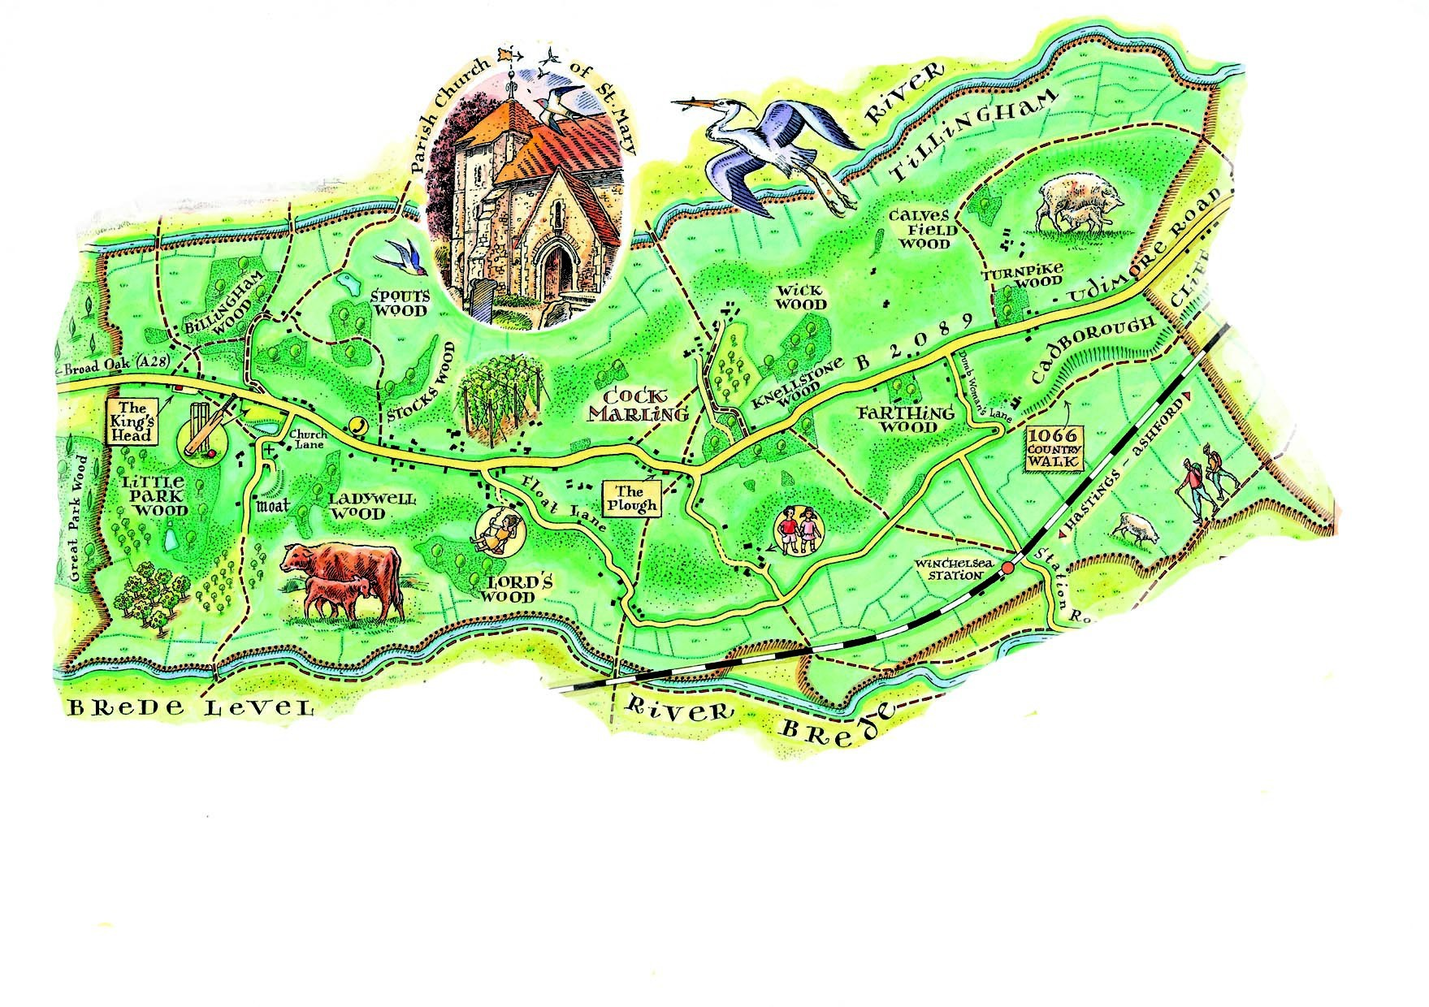
Udimore Parish Council Newsletter
www.udimore.org Issue 25 May 2017
Next Council meeting  The Parish Council will meet on  Wednesday 17th March 2017 at 7.15pm in Udimore Community Hall. The meeting will be preceded by the Annual Parish Assembly at 6.30pm  All are welcome to attend | ‘Your Udimore’ event  This was held on 29th April and attracted a large number of visitors. Those attending had the opportunity to leave questions for the Parish Council and other organisations active in the village Those questions were addressed to the parish council all of which were anonymous. The questions were as follows:  Q. Is there any affordable housing for young people in Udimore?  A. The short answer is no. unlike some other nearby villages, there is no pressure for housing development in Udimore. In its strategy plan, Rother District Council have not identified any sites in Udimore as potentially suitable for housing development. If any applications for developments were made in the future, they would be considered by Rother District Council. The parish council and local residents would have the opportunity to make their views known.  Q. Footways and hedges should be cut back to allow safer exit/entry onto the B2089.  A. It is the responsibility of landowners to ensure hedges alongside the road are cut back so that they do not obstruct traffic. The parish council and the local highway steward, who works for the county council, keep their eyes on hedges and take action if necessary. Hedges should not be cut during the bird nesting season which extends to the end of July.  Q. How can we make it safer to walk down the main road in the village?  A. In the past the parish council has looked at the provision of footpaths along the road. The conclusion was that it would be impossible to provide extended lengths of footpaths without land acquisition and the room au some existing hedges. This would make the cost prohibitive. Speeding traffic makes use of the road by motorists, cyclists and pedestrians dangerous. Enforcement of speed limits is matter for the police. Inspector Dan Russell from Sussex Police will attend the Annual Parish Assembly on Wednesday 17th May at 6.30pm in the Community Hall. Please come and put your questions to him.
The agenda at a glance:

Defibrillator

Community event in April

Your councillors
Bob Turgoose, Chairman
01424 882657 bobturgoose@yahoo.co.uk
Keith Dean, Vice Chairman
01424 882206 kdean@clfarm.co.uk
Leonie Wheeler
01797 222009 wheelersflp@googlemail.com
Louise Fuller
07753 565122
louandtez@gmail.com
Diane Hayes
01797 229734
tnd.hayes@btopenworld.com

Clerk: Sarah Willoughby 01424 813785/05755 126837 email: udimorepc@hotmail.co.uk Parish council website: www.udimore.org Newsletter editor: Bob Turgoose

Udimore planning applications.

All planning applications are decided by Rother District Council.
Udimore Parish Council is always notified of new applications in the parish so that it can submit relevant local information or comments to the planning department at Rother DC.
Since your last newsletter there has been one planning application:

Applications:
RR/2017/322/P - Ladywell - Land opposite, Church Lane, Udimore TN31 6BB Demolish existing fire damaged steel from barn and erect new steel frame barn with concrete paved access. Decision by 12th April 2017
Decisions:
RR/2017/3212/P Rose Cottage, Udimore Road. Construct an additional separate vehicular access parallel to the existing in order to form an independent access to the field. Granted.

Full details of all applications and decisions can be found at www.rother.gov.uk

Defibrillator

It has been suggested that Udimore should acquire a defibrillator. The cost would be about £1,000 plus installation. The council are considering the practical aspects of a defibrillator including where it would be located and how residents would be informed of its location and use.

A defibrillator is designed to help someone who has suffered a heart attack until the ambulance service can attend. The advice we have seen indicates that in these circumstances the first two to three minutes after an attack are vital; the defibrillator should be used in this period and other first aid also applied.

Forthcoming parish council meetings will be held in Udimore community hall at 6.30pm on the following dates:
2017 2018
15th March 17th January
17th May 21st March
19th July 16th May
20th September 18th July
22nd November 19th September
21st November

