2019

Udimore Parish Council

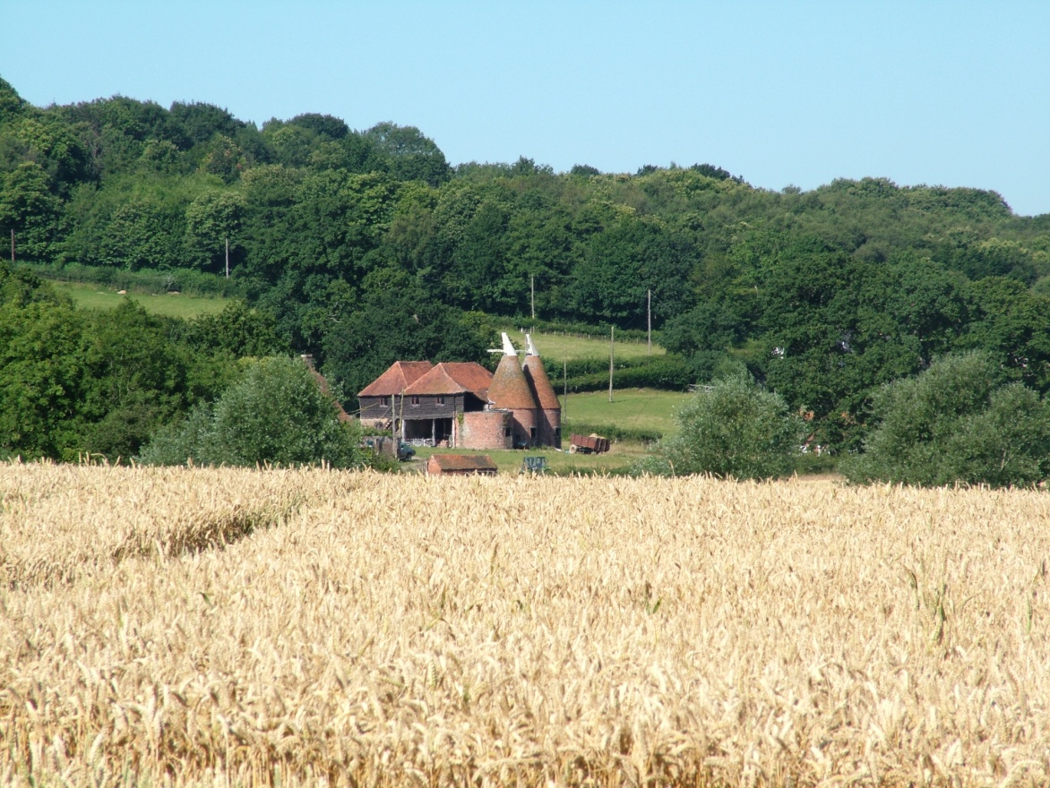
Information for residents
Welcome to Udimore
UDIMORE PARISH COUNCIL WELCOMES ALL NEW RESIDENTS

A message from the Parish Council Chairman
Welcome to Udimore. I hope you will enjoy becoming a part of our village. This information has been put together to help new residents to access services, learn about their immediate locality and feel part of the community.

Udimore is reputed to be the second longest village in the UK and stretches from just west of the King’s Head public house almost into Rye at Cadborough Farm. The geographical layout of the village and the volume of traffic on the B2089 may make it difficult to meet your neighbours, but there is a vibrant community which will make you welcome if you choose to get involved. In 2010 a new hall was completed for the use of St Mary’s church and the community. It was a long time arriving, but now we have it and are making good use of it. We are fortunate to have two pubs to choose from. In addition to the King’s Head there is The Plough at Cock Marling, part of the Parish of Udimore. In these pages we hope to answer some immediate questions you may have and all Parish Council members look forward to meeting you personally at one of our community events or at Parish Council meetings held in the hall. Bob Turgoose

CONTENTS of this Welcome Pack: Page
- Portrait of an East Sussex Village 2/3
- History of Udimore 3
- St Mary’s Church 3
- Transport 3/4
- Parish Council 4
- Education 4
- Clubs and activities 4
- Local Action Plan 4
- Directory- List of useful service providers 5
- Acknowledgements, and parish map 6

Portrait of an East Sussex Village
Situated in the High Weald Area of Outstanding Natural Beauty, just west of the historic port of Rye, the village sits astride the ridge running between the River Tillingham to the north and the River Brede to the south, providing beautiful views over pastoral Sussex. The Brede and Tillingham valleys were once seawater estuaries and conduits for cargoes of timber, iron and farm produce. Over the last 500 years, the waterways have been channelled, sluiced and drained, providing broad, fertile valley bottoms for pasture and arable farming. Along the ridge, the characteristic Wealden pattern of coppiced woods and seasonal pasture has hardly been disturbed since medieval times.
The identity of the village is primarily rural residential. There are many beautiful old dwellings dating from the 15th Century through to the Victorian era and later, some of which are of significant architectural and historical interest. Several working farms produce sheep, cattle, soft fruit and hops, with one orchard growing apples and pears.
Although there is no village centre and no longer a Post Office, shop, garage, nor many buses, there is a privately run nursery school, two pubs and other small enterprises, including several artists who live and work in the village.
In 2011 the population profile was:
- 369 people, in 159 households
- 0 to 14 years – 12.5% (46)
- 15 to 64 years – 58.5% (216)
- 65 and over – 29% (107)
The population has changed little in the last 150 years. In 1851 it was 374 and in 1965 it was 391. The area of the village is 1,171 hectares, with a population density of 0.3 persons per hectare.
History of Udimore
Recently arrived residents are often interested to find out about the history of their new surrounds. Local historian Harold Moores has set up a website to share a wealth of historical information. Please visit www.udimorehistory.org to find out how your community has changed over time. The website aims to be a modern, effective method of recovering and organising historical information about Udimore, and to promote understanding and cooperation between the generations currently living in Udimore. Residents are encouraged to contribute ideas, reminiscences, photos (for scanning and returning), anecdotes and family connections, so that the history of this unique ancient village will not be lost.

St Mary’s Church
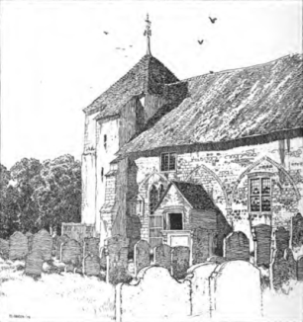
St Mary’s is the sister church of St George’s in Brede. The second Sunday of every month is our family service at 11.15am, which is open to all ages especially children. We have a cup of coffee afterwards in the Hall so this is a good place to meet members of the village. Please refer to the Parish Magazine to advertise forthcoming events and for the times of services at St Mary’s, St George’s and Broad Oak Methodist church. The annual subscription for ten issues is £5.00. Contact Elizabeth St Claire-George, the editor, at parishmagazineinbox@gmail.com.

Transport
Udimore has few buses running through the village. The 340 and 342 services run between Hastings and Rye and stop in the village. Details of all services in the local area with current timetables may be obtained from the Visitor Centre in Priory Meadow, Hastings or on the website www.traveline.info

There are two designated bus stops in Udimore, one outside The Plough and one just to the west of the junction of Float Lane and Udimore/Rye Road. ‘Fixtures’ is a free publication available in Rye which also contains the time tables of local buses.
The Rye Community Bus service, can be hailed down outside your house – if you live on the B2089 and the times of this service can be obtained by phoning 01797 227722.
There is also a bus that runs through the village to Tesco in Hastings on Tuesday mornings.

Jempsons’ Bus, goes to and from their store in Peasmarsh. Pick up is on Saturdays at 8:59 from The Kings Head, with a return journey leaving the store at 11:00 (with a charge for this service of £1.00)

Rail links from Rye to Ashford or Hastings connect with the fast routes to London. From Ashford International you can access Eurostar trains to Europe. An alternative route to London is from Hastings to Charing Cross and the nearest station is Robertsbridge, about twenty minutes by car. Please see National Rail timetables for these train times. “Fixtures” magazine also has the timetables for Eurostar.

Shopping
The nearest towns for general shopping are Rye, 3 miles to the east, and Hastings 10 miles to the west of Udimore. Several local villages provide amenity stores for general grocery shopping and Jempsons in Peasmarsh has both supermarket and a petrol station.

Udimore Parish Council (as at January 2019)
Chairman: Mr Bob Turgoose 01424 882657
Vice Chairman: Louise Fuller 07753 565122
Councillors: Diane Hayes 01797 229734; Leonie Wheeler 01797 222009; Keith Dean 01424 882206

The Parish Clerk is Sarah Willoughby Telephone number 01424 813785 or email on udimorepc@hotmail.co.uk

The Parish Council usually meets in January, March, May, July, September and November on the 3rd Wednesday of those months. For agendas, minutes and meeting dates visit the parish website www.udimore.org The website also has details of local events and matters of topical interest. The next Parish Council elections will be in May 2019.

Rother District Council is our local authority. Its website is www.rother.gov.uk
East Sussex County Council website is www.eastsussex.gov.uk

East Sussex County Council is responsible for highways, education, child and adult social services and libraries. The nearest library is in Rye.

Our District and County Councillors are:
Jonathan Johnson
Tel: 01424 882414; email cllr.jonathan.johnson@rother.gov.uk
Carl Maynard
Tel: 01424 752178; email cllr.carl.maynard@rother.gov.uk
Carl Maynard is our local county councillor.

Education
For information about schools throughout the county visit the East Sussex County Council website. www.eastsussex.gov.uk/educationandlearning
For local schools see the Village Directory on page 5

Clubs and activities
Various ideas for clubs and activities came forward from the community during the Local Action Plan consultations. The Hall has a wide range of users including Yoga classes, Pilates, dance exercise and ballroom classes. There is a children’s drama group and a decorative stitch group. Telephone numbers of some of these groups are below.
Udimore Footpaths group – Louise Fuller on 07753 565122
Craft and Chatter – Bill Rathery 01424 882774
Vocality, our singing group – Nadia Florence-Marshal 01424 882948
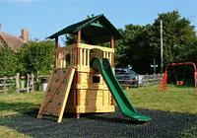
There is a children’s playground in Float Lane.

Local Action Plan
Consultations took place with all residents to arrive at a plan of actions for the village that would have wide support. The process was supported by the Parish Council and the final plan covers twelve key issues involving transport, environment, community, and younger residents. The plan was published in 2010 and a copy is available on the Parish Council website. www.udimore.org The Parish Council undertook a review of the plan in September 2012 and a report of the achievements up to that time is also available on the website.

Village Directory

(Contact details are provided for information only and do not indicate Parish Council endorsement)

Name | Service / business & website | Address / Tel. no.
The Plough | Public House | Udimore Road 01797 223381
The King's Head | Public House | Udimore Road 01424 882116
Sussex Police | Non- emergency  www.sussex.police.uk | 101
Sussex Police | Emergency | 999
Northiam and Broad Oak Surgery | General Practitioner  www.northiamandbroadoaksurgery.co.uk | Reedswood Road, Broad Oak, TN31 6DH tel: 01424 882394
Northiam and Broad Oak Surgery | General Practitioner  www.northiamandbroadoaksurgery.co.uk | Main Street, Northiam  01797 252140
Ferry Road Health Centre | General Practitioner  www.ferryroadhealthcentre.net | Ferry Road, Rye  01797 223230
Rye Medical Centre | General Practitioner  www.ryemedicalcentre.com | Rye Foreign  01797 223333
Udimore Community Hall  St Mary’s Hall  TN31 6BB | Hall Manager,  Frank Langrish  udimorehallbooking@gmail.com | 07976 255431
Roadend Nursery School | Pre-school nursery | Roadend Farm, Udimore Tel: 01797 226116
Brede Primary School | Nearest ESCC primary school | Udimore Rd, Broadoak, TN31 6DG Tel: 01424 882393
Rye College | Nearest ESCC secondary school | The Grove, Rye Tel: 01797 222545

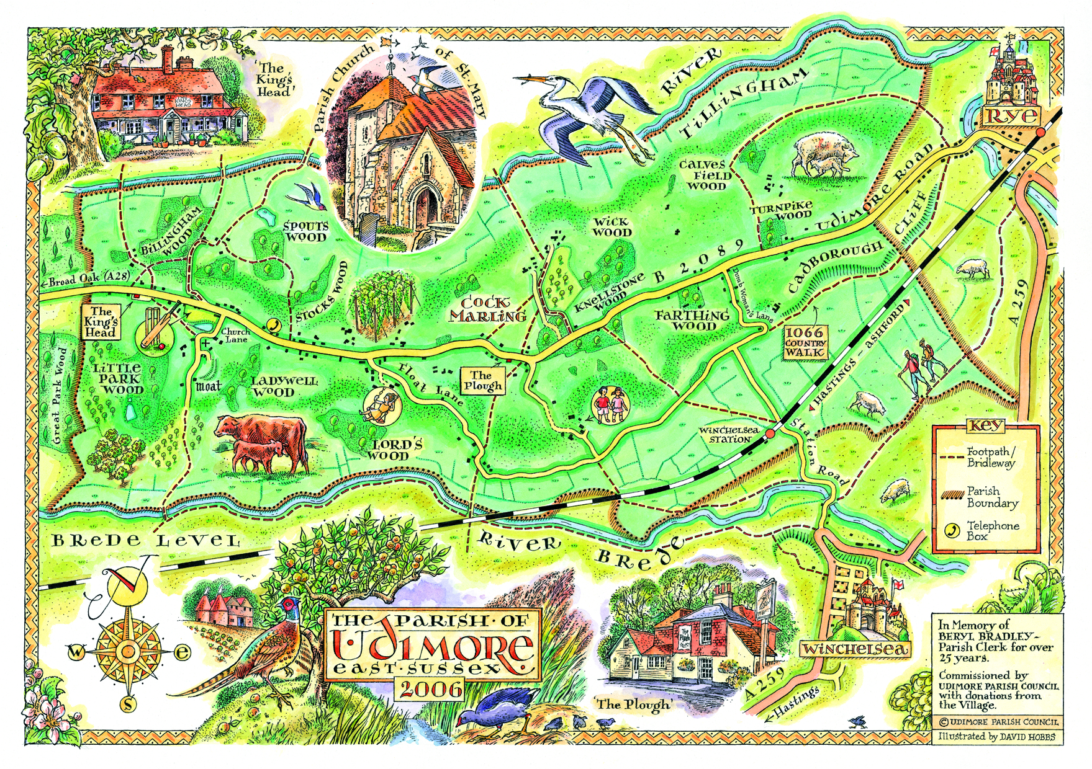

Acknowledgements: This information was put together by several residents, especially
Mrs Nadia Florence-Marshall whose contribution is gratefully acknowledged.

